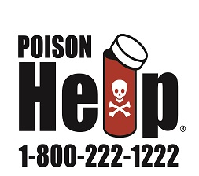
A message from Pam Murphy, PES School Nurse
I’ll never forget the first time I called Poison Control. My older daughter came running into the house to tell me that, while at a neighbor’s house, her 4 year old sister had eaten a mushroom from the yard. I called Poison Control, answered their questions and received reassuring information – she had not eaten enough to be harmful. What a relief.
The Northern New England Poison Center, located in Portland Maine, serves New Hampshire, Maine and Vermont. 1-800-222-1222 is a free, 24-hour poison emergency and information help line, They may also be reached via by online chat at www.PoisonHelp.org or by texting POISON to 85511. They give free, confidential, expert medical advice 24 hours a day, seven days a week.
So, if you have a poison emergency, want to ask a question about possible poisons or desire education about poison prevention, contact Northern New England Poison Center.

